# Program 8: Implement simple linear regression

import numpy as np

import matplotlib.pyplot as plt

import pandas as pd

data_set= pd.read_csv(r"C:\Users\BASAPPA SIR\Desktop\Dataset\Salary_Data.csv")

x= data_set.iloc[:, :-1].values

y= data_set.iloc[:, 1].values

print(x)

print(y)

from sklearn.model_selection import train_test_split

x_train, x_test, y_train, y_test= train_test_split(x, y, test_size= 1/3, random_state=0)

from sklearn.linear_model import LinearRegression

regressor= LinearRegression()

regressor.fit(x_train, y_train)

y_pred= regressor.predict(x_test)

x_pred= regressor.predict(x_train)

x_pred

plt.scatter(x_train, y_train, color="green")

plt.plot(x_train, x_pred, color="red")

plt.title("Salary vs Experience (Training Dataset")

plt.xlabel("Years of Experience")

plt.ylabel("Salary(In Rupees)")

plt.show()

plt.scatter(x_test, y_test, color="blue")

plt.plot(x_train, x_pred, color="red")

plt.title("Salary vs Experience (Test Dataset)")

plt.xlabel("Years of Experience")

plt.ylabel("Salary(In Rupees)")

plt.show()

**output:**

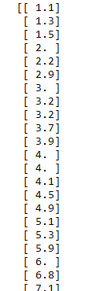

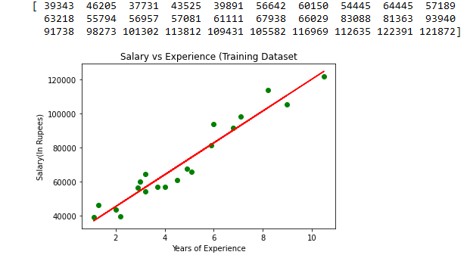 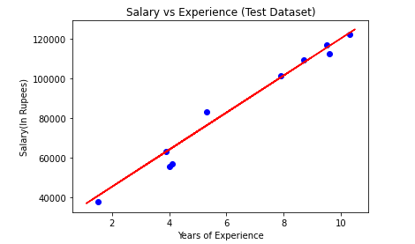

**Program 9: Implement multiple regression**

**#Multiple Regression**

import numpy as np

import matplotlib.pyplot as lpt

import pandas as pd

data_set= pd.read_csv("C:\\Users\BASAPPA SIR\\Desktop\\Dataset\\50_Startups.csv")

x= data_set.iloc[:, :-1].values

y= data_set.iloc[:,1].values

from sklearn.preprocessing import LabelEncoder, OneHotEncoder

labelencoder_x= LabelEncoder()

x[:,2]= labelencoder_x.fit_transform(x[:,2])

onehotencoder= OneHotEncoder()

x= onehotencoder.fit_transform(x).toarray()

print(x)

from sklearn.model_selection import train_test_split

x_train, x_test, y_train, y_test= train_test_split(x, y, test_size= 0.2, random_state=0)

from sklearn.linear_model import LinearRegression

regressor= LinearRegression()

regressor.fit(x_train, y_train)

#Predicting the Test set result;

y_pred= regressor.predict(x_test)

print('Train Score: ', regressor.score(x_train, y_train))

print('Test Score: ', regressor.score(x_test, y_test))

fig = plt.figure(figsize=(10, 6))

plt.scatter(y_test, y_pred)

plt.xlabel('Position Levels')

plt.ylabel('Predicted values')

plt.title('Actual vs. Predicted Values')

plt.plot([min(y_test), max(y_test)], [min(y_test), max(y_test)], linestyle='--', color='blue')

plt.show()

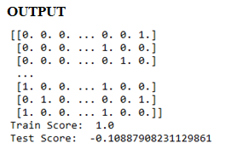

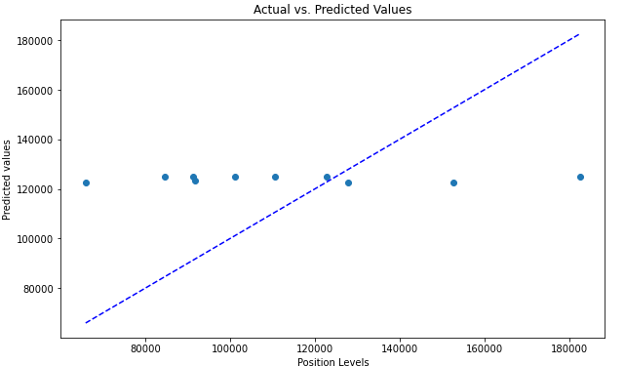

# Program 10: Implement polynomial regression

**#polynominal program**

import numpy as np

import matplotlib.pyplot as plt

import pandas as pd

data_set= pd.read_csv("C:\\Users\BASAPPA SIR\\Desktop\\Dataset\\Salary_Data.csv")

x= data_set.iloc[:, :-1].values

y= data_set.iloc[:, 1].values

from sklearn.linear_model import LinearRegression

lin_regs= LinearRegression()

lin_regs.fit(x,y)

from sklearn.preprocessing import PolynomialFeatures

poly_regs= PolynomialFeatures(degree= 2)

x_poly= poly_regs.fit_transform(x)

lin_reg_2 =LinearRegression()

lin_reg_2.fit(x_poly, y)

plt.scatter(x,y,color="blue")

plt.plot(x,lin_regs.predict(x), color="red")

plt.title("Bluff detection model(Linear Regression)")

plt.xlabel("Position Levels")

plt.ylabel("Salary")

plt.show()

plt.scatter(x,y,color="blue")

plt.plot(x, lin_reg_2.predict(poly_regs.fit_transform(x)), color="red")

plt.title("Bluff detection model(Polynomial Regression)")

plt.xlabel("Position Levels")

plt.ylabel("Salary")

plt.show()

**OUTPUT**

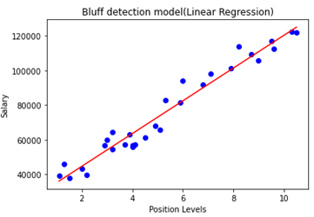 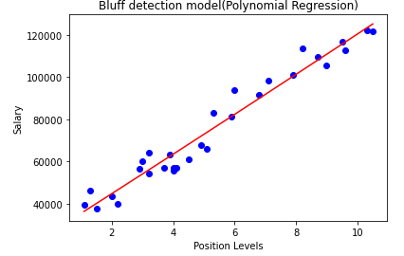

# Program 11: Implement Decision Tree

# Decision Tree Program

# importing libraries

import numpy as np

import matplotlib.pyplot as lpt

import pandas as pd

#importing datasets

data_set= pd.read_csv(r'C:\Users\BASAPPA SIR\Desktop\Dataset\user_data.csv')

#Extracting Independent and dependent Variable

x= data_set.iloc[:, [2,3]].values

y= data_set.iloc[:, 4].values

print(y)

# Splitting the dataset into training and test set.

from sklearn.model_selection import train_test_split

x_train, x_test, y_train, y_test= train_test_split(x, y, test_size= 0.25, random_state=0)

#feature Scaling

from sklearn.preprocessing import StandardScaler

st_x= StandardScaler()

x_train= st_x.fit_transform(x_train)

x_test= st_x.transform(x_test)

#Fitting Decision Tree classifier to the training set

from sklearn.tree import DecisionTreeClassifier

classifier= DecisionTreeClassifier(criterion='entropy', random_state=0)

classifier.fit(x_train, y_train)

#Predicting the test set result

y_pred= classifier.predict(x_test)

#Creating the Confusion matrix

from sklearn.metrics import confusion_matrix

cm= confusion_matrix(y_test, y_pred)

print(cm)

#Visulaizing the trianing set result

from matplotlib.colors import ListedColormap

x_set, y_set = x_train, y_train

x1, x2 = nm.meshgrid(nm.arange(start = x_set[:, 0].min() - 1,

stop = x_set[:, 0].max() + 1, step =0.01), nm.arange(start = x_set[:, 1].min() - 1,

stop = x_set[:, 1].max() + 1, step = 0.01))

lpt.contourf(x1, x2, classifier.predict(nm.array([x1.ravel(), x2.ravel()]).T).reshape(x1.shape),

alpha = 0.75, cmap = ListedColormap(('purple','green' )))

lpt.xlim(x1.min(), x1.max())

lpt.ylim(x2.min(), x2.max())

for i, j in enumerate(nm.unique(y_set)):

lpt.scatter(x_set[y_set == j, 0], x_set[y_set == j, 1],

c = ListedColormap(('purple', 'green'))(i), label = j)

lpt.title('Decision Tree Algorithm (Training set)')

lpt.xlabel('Age')

lpt.ylabel('Estimated Salary' )

lpt.legend()

lpt.show()

**OUTPUT:**

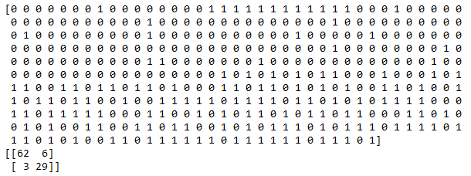

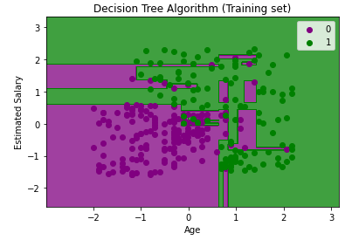

# Program 12: Implement Random Forest

**# Random Forest**

**# importing libraries**

import numpy as np

import matplotlib.pyplot as lpt

import pandas as pd

**#importing datasets**

data_set= pd.read_csv(r'C:\Users\BASAPPA SIR\Desktop\Dataset\user_data.csv')

**#Extracting Independent and dependent Variable**

x= data_set.iloc[:, [2,3]].values

y= data_set.iloc[:, 4].values

**# Splitting the dataset into training and test set.**

from sklearn.model_selection import train_test_split

x_train, x_test, y_train, y_test= train_test_split(x, y, test_size= 0.25, random_state=0)

**#feature Scaling**

from sklearn.preprocessing import StandardScaler

st_x= StandardScaler()

x_train= st_x.fit_transform(x_train)

x_test= st_x.transform(x_test)

**#Fitting Decision Tree classifier to the training set**

from sklearn.ensemble import RandomForestClassifier

classifier= RandomForestClassifier(n_estimators= 10, criterion="entropy")

classifier.fit(x_train, y_train)

**#Predicting the test set result**

y_pred= classifier.predict(x_test)

**#Creating the Confusion matrix**

from sklearn.metrics import confusion_matrix

cm= confusion_matrix(y_test, y_pred)

print(cm)

**#Visualizing the training Set resultfrom matplotlib.colors import ListedColormap**

from matplotlib.colors import ListedColormap

x_set, y_set = x_train, y_train

x1, x2 = np.meshgrid(np.arange(start = x_set[:, 0].min() - 1, stop = x_set[:, 0].max() + 1, step =0.01),

nm.arange(start = x_set[:, 1].min() - 1, stop = x_set[:, 1].max() + 1, step = 0.01))

lpt.contourf(x1, x2, classifier.predict(np.array([x1.ravel(), x2.ravel()]).T).reshape(x1.shape),

alpha = 0.75, cmap = ListedColormap(('purple','green' )))

lpt.xlim(x1.min(), x1.max())

lpt.ylim(x2.min(), x2.max())

for i, j in enumerate(np.unique(y_set)):

lpt.scatter(x_set[y_set == j, 0], x_set[y_set == j, 1],

c = ListedColormap(('purple', 'green'))(i), label = j)

lpt.title('Random Forest Algorithm (Training set)')

lpt.xlabel('Age')

lpt.ylabel('Estimated Salary')

lpt.legend()

lpt.show()

**OUTPUT**



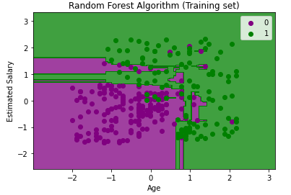

**Program 13: DATA VISUALIZATION USING PYTHON**

**BAR CHART**

import matplotlib.pyplot as plt

import pandas as pd

x = ['Grocery','Rent','Education of Children','Medicine','Fuel', 'Entertainment',' Miscellaneous']

y = [4,5,5,2,2,1,1]

plt.bar(x, y, color='green',edgecolor='blue',linewidth=2)

plt.title("Family Monthly plan")

plt.ylabel('Expenditure (in thousand rupees)')

plt.xlabel('Heads')

plt.xticks(x, rotation=45)

plt.show()

**OUTPUT**

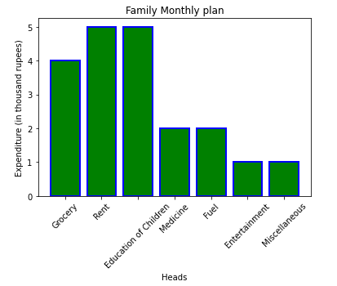

**HISTOGRAM**

import matplotlib.pyplot as plt

x=[22, 87, 5, 43, 56, 73, 55, 54, 11, 20, 51, 5, 79, 31, 27]

plt.hist(x, bins=[0,20,40,60,80,100], color='green', edgecolor='red', linestyle='-')

plt.title("Dataset")

plt.ylabel('Frequency')

plt.xlabel('Total Bill')

plt.show()

**OUTPUT**

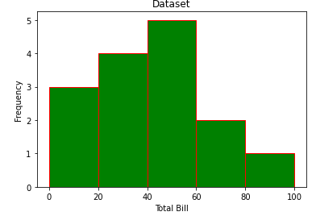

**HISTOGRAM**

import matplotlib.pyplot as plt

cars=['AUDI','BMW','FORD','TESLA','JAGUAR']

data=[23,13,35,15,12]

explode=[0.1,0.5,0,0,0]

colors=("orange","cyan","yellow","grey","green",)

plt.pie(data,labels=cars,explode=explode,autopct='%1.2f%%',colors=colors,shadow=True)

plt.show()

**OUTPUT**

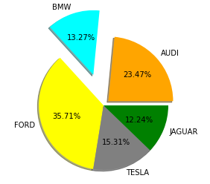

**SCATTER PLOT:**

import matplotlib.pyplot as plt

price = [2.50, 1.23, 4.02, 3.25, 5.00, 4.40]

sales = [34, 62, 49, 22, 13, 19]

plt.scatter(price, sales, c='RED', s=60,marker='D', alpha=1)

plt.title("Dataset")

plt.ylabel('price')

plt.xlabel('sales')

plt.show()

plt.show()

**OUTPUT**

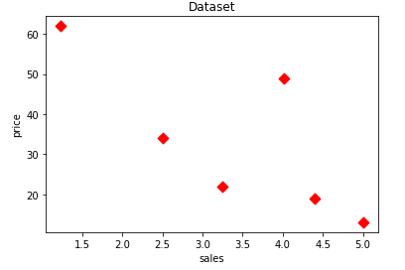

**Line Graph:**

import matplotlib.pyplot as plt

x = [10, 20, 30, 40]

y = [20, 25, 35, 55]

plt.title=('LINE CHART')

fig = plt.figure(figsize =(7, 5), facecolor='g',edgecolor='b', linewidth=7)

ax = fig.add_axes([1, 1, 1, 1])

ax.plot(x, y)

plt.xticks(x, labels=["one", "two", "three", "four"])

plt.plot(x, y, color='green', linewidth=3, marker='o',markersize=15, linestyle='--')

plt.legend(["GFG"])

fig = plt.figure(figsize =(5, 4))

ax1 = fig.add_axes([0.1, 0.1, 0.8, 0.8])

ax2 = fig.add_axes([1, 0.1, 0.8, 0.8])

ax1.plot(x, y)

ax2.plot(y, x)

plt.ylabel('Y-Axis')

plt.xlabel('X-Axis')

plt.ylim(0,80)

plt.subplot(122)

plt.plot(y,x)

plt.subplot(121)

plt.plot(x,y)

**OUTPUT**

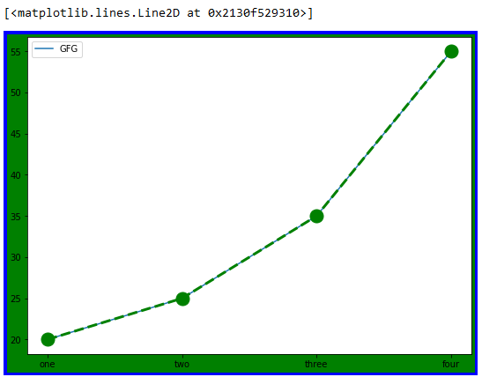

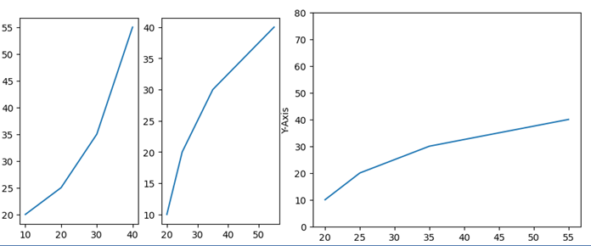

import pandas as pd

import matplotlib.pyplot as plt

import numpy as np

import seaborn as sns

data_set=pd.read_csv(r"C:\Users\BASAPPA SIR\Desktop\Dataset\salary_Data.csv")

display(data_set)

sns.scatterplot(x="YearsExperience",y="Salary",data=data_set)

